+
Third year (Second Semester).

OSCE Exam (Objective Structured Clinical Examination). (A1)
Student's Name:
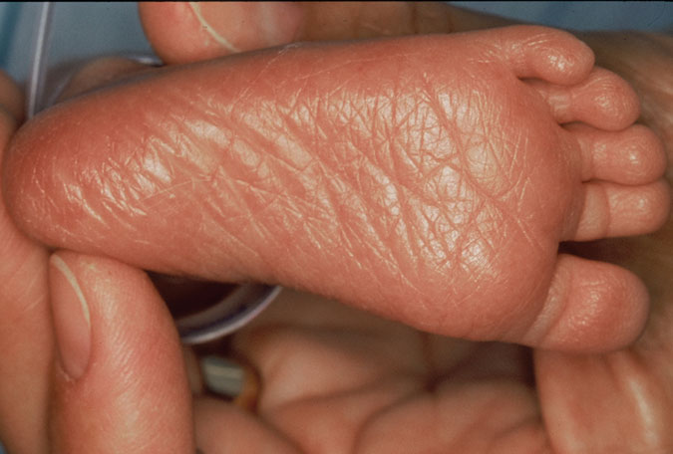
- This picture describes apart of physical assessment of gestational age which is ----------------------------------------
(2 scores)

- List ABCD’s of resuscitation (3 scores)
- -----------------------------
- ------------------------------
- ------------------------------
- ------------------------------

Third year (Second Semester).

OSCE Exam (Objective Structured Clinical Examination). (B1)
Student's Name:
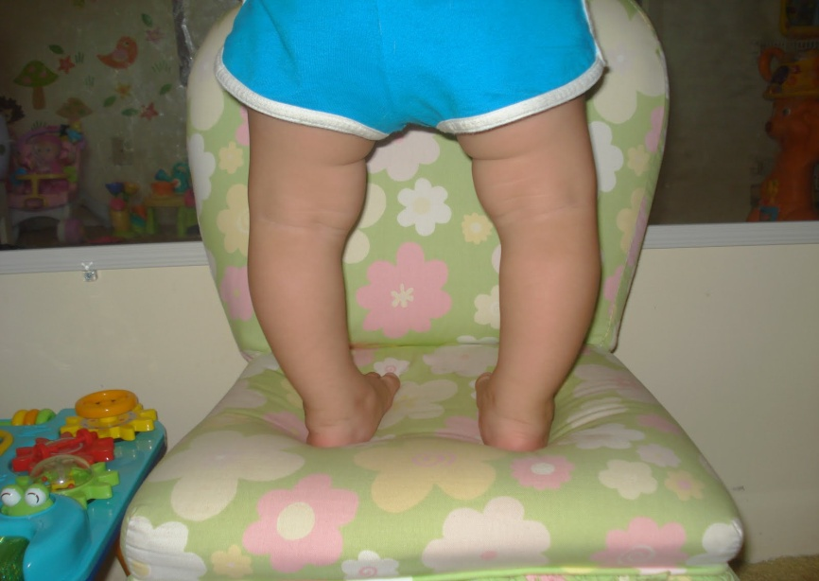
- This picture describes a deformity which is -------------------------------------------------------------
(3 scores)

Put True and false
3-Eructate or bubble infant during and after feeding
(2scores)

Third year (Second Semester).

OSCE Exam (Objective Structured Clinical Examination). (C1)
Student's Name:
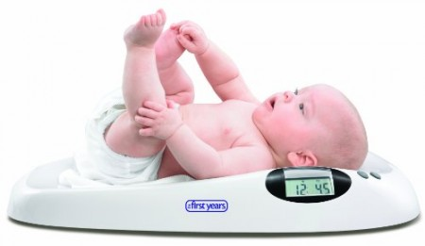

This picture describe ------------------------------------------------------------------------------------- (2 scores)

6-chloride use as disinfectant solution daily care for incubator
(2 scores)

Third year (Second Semester).

OSCE Exam (Objective Structured Clinical Examination). (D1)
Student's Name:
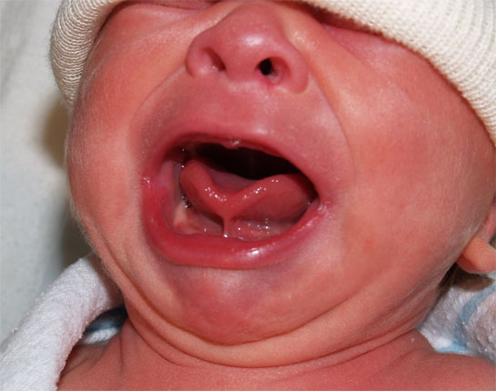
- This abnormality is called ------------------------------------------------------------------ (3 scores)

(2 scores)
Complete the following:-
- Estimation of gestational age is occurred through
- …………………………
- …………………………

Third year (Second Semester).

OSCE Exam (Objective Structured Clinical Examination). (A2)
Student's Name:

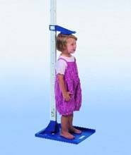
- This Picture describe one of growth measurements which is called -------------------------------------------------------------------------------------------
(3 scores)

- If heart rate is less than 60 b\m, you should
- ------------------------------------------------------
- -------------------------------------------------------
(2 scores)

Third year (Second Semester).

OSCE Exam (Objective Structured Clinical Examination). (B2)
Student's Name:

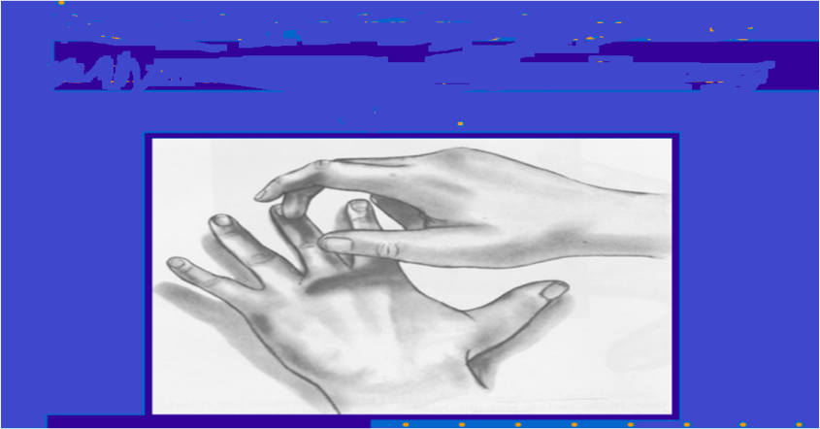
-write the type of this tool? (2 scores)
(1)-Tool name:

- New Ballard score include
1-……………………………. assessment
2-……………………………..assessment
(3 scores)

Third year (Second Semester).

OSCE Exam (Objective Structured Clinical Examination). (C2)
Student's Name:
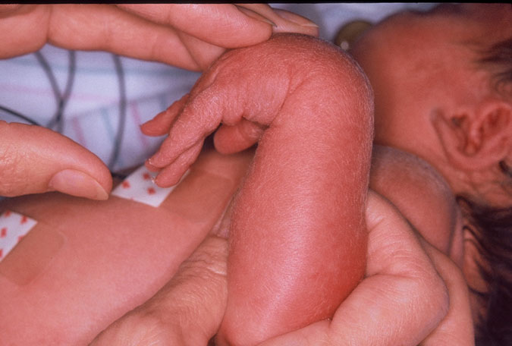
- This picture describes apart of neuromuscular assessment of gestational age which is ----------------------------------------
(3 scores)

True and false:-
10-Nurse assessment of the child every 15min include discontinuation restrain
(2 scores)

Third year (Second Semester).

OSCE Exam (Objective Structured Clinical Examination). (D2)
Student's Name:
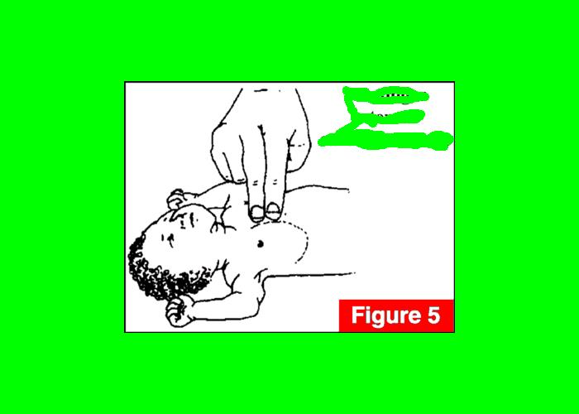
- This procedure is a part of resuscitation which is called ------------------------------------------------
- (2 scores)
Choose correct answer
1-Normal pulse child 2years
(80-130)
(170-110)
(100-70)
(80-120)
( )
(1 scores)

Third year (Second Semester).

OSCE Exam (Objective Structured Clinical Examination). (A3)
Student's Name:
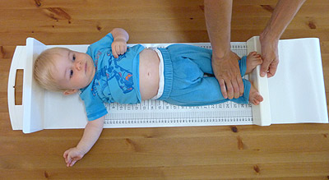
- This Picture describe one of growth measurements which is-----------------------------------------------------------------------------------------------------------------
(2 scores)

- Resuscitation is defined as------------------------------------------------------------------------------------------------------------------------------------

(3 scores)

Third year (Second Semester).

OSCE Exam (Objective Structured Clinical Examination). (B3)
Student's Name:
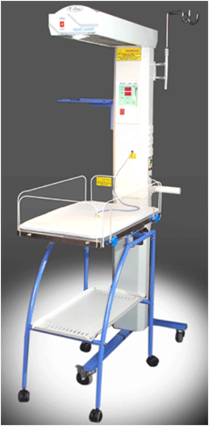

- This set is called --------------------------------------------------------------------
(2 scores)

Choose the correct answer
- The following drugs can be given to a resuscitated child through ETT
- adrenaline
- calcium gluconate
- sodium bicarbonate
- atropine
- 1 and 4
- None of these
(3 scores)

Third year (Second Semester).

OSCE Exam (Objective Structured Clinical Examination). (C3)
Student's Name:

- This procedure is a part of resuscitation which is called ------------------------------------------------
(2 scores)

-Indication for insertion of NGT
1- ------------------------------------------------
2- ------------------------------------------------
(3 scores)

Third year (Second Semester).

OSCE Exam (Objective Structured Clinical Examination). (D3)
Student's Name:

Fill in the links the tools of physical examination: (3 scores)
1-
2-
3-
4-
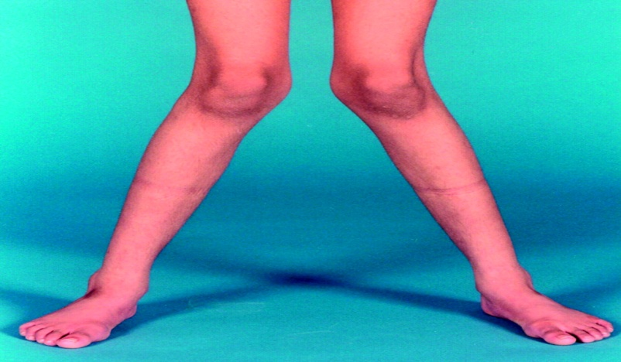
This picture describes a deformity which is called------------------------------------------------------------------- (2 scores

Choose correct answer
Nasogastric tube may be left in place for .......days
{ (3-4),(5-6),(2-6),(3-7) }

